**Lab Introduction:**

In this lab we’ll be learning about wireless networking using Cisco Packet Tracer.

**Objectives:**

* To learn what wireless networking is
* How wireless networking works

**Index**

|  |  |  |
| --- | --- | --- |
| Experiment No. | Experiment Title | Page |
| 01 | Simulating Wireless Networking in Cisco Packet Tracer | 2 |

**Experiment No.: 1**

**Experiment Title: Simulating Wireless Networking in Cisco Packet Tracer.**

**Objectives:**

* To learn what wireless networking is
* How wireless networking works

**Discussion:**

[Wireless networking is a method or process of connecting network nodes or devices without using cables of any kind](https://www.bing.com/ck/a?!&&p=fe3ede2771a9a71aJmltdHM9MTY4MTM0NDAwMCZpZ3VpZD0zZDNlMjZlMi00ZThmLTZmNmQtMWNmMi0zNDQyNGY4ZTZlYjMmaW5zaWQ9NTg1MA&ptn=3&hsh=3&fclid=3d3e26e2-4e8f-6f6d-1cf2-34424f8e6eb3&psq=wireless+networking&u=a1aHR0cHM6Ly9lbi53aWtpcGVkaWEub3JnL3dpa2kvV2lyZWxlc3NfbmV0d29yaw&ntb=1" \o "en.wikipedia.org" \t "https://www.bing.com/_blank). Wireless networks use electromagnetic waves or radio frequency (RF) connections to transmit data through free space. Wireless networking can avoid the costly and difficult installation of cables in buildings or between equipment locations.

**Methodology:**

* Create the network topology.
* Configuration of the Network Nodes.
* Choose the Statistics.
* Run the Simulation.
* Analysis of the Results.

**Working procedure:**

1. **Giving the geometric shape of the topology**
   1. Taken devices
2. Two desktop PCs
3. 2950-24 Switch
4. 1841 Router
5. Laptop
6. Tablet PC
7. AccessPoint-PT

Connecting 1 PC to the switch, and the switch to the router and the Access Point with straight through copper cable, as they are different typed devices via Fast Ethernet port.

Now turning off PC1, remove the removable port and replace it with WMP300N module, which provides one 2.4GHz wireless interface suitable for connection to wireless networks. The module supports protocols that use Ethernet for LAN access.

Then turn on the PC.

Now turning off laptop0, remove the removable port and replace it with WPC300N module, provides one 2.4GHz wireless interface suitable for connection to wireless networks. The module supports protocols that use Ethernet for LAN access.

Then turn on the laptop.

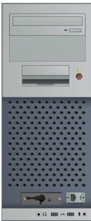

Fig 1.1: Rear view of the PC after installing WMP300N in CPT.

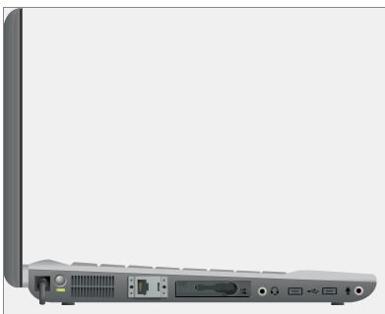

Fig 1.2: Rear view of the laptop after installing WPC300N in CPT.

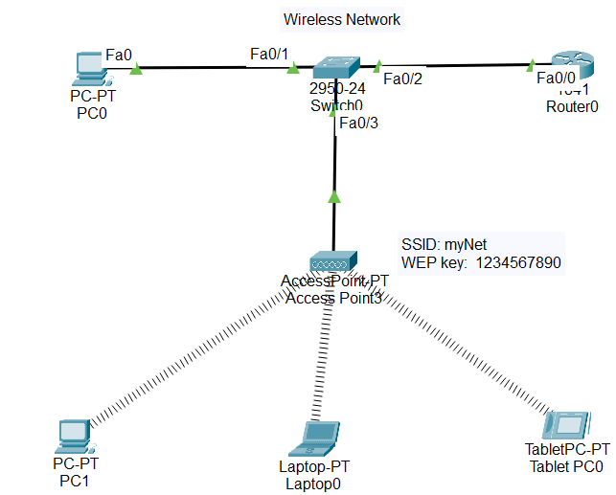

Fig 1.3: Simulating the topology using CPT.

1. **Configuring the devices**
   1. Configuring the access point

Go to ‘Prt 1’;

Set SSID such as, “myNet”

From the Authentication field, select WEP and give a 10 hexadecimal digits long WEP key such as, “1234567890”

If the end devices are configured before connecting them with the wireless network, we're going to have to configure them again after setting up the wireless connection. So, it’s better to configure them later in this packet tracer tool.

* 1. connecting PC1, Laptop0 and Tablet PC0 with the access point remotely

For PC1 and Laptop0, go to from the ‘Desktop’ field to the ‘PC wireless’, from which enter the ‘Connect’ field and hit ‘Refresh’ button. In a matter of seconds, the SSID given in the access point, “myNet”, will show up to the left-side-box. Select “myNet” and hit the ‘Connect’ button.

Then in the next window, in the ‘WEP key 1’ field enter the WEP key given in the access point, “1234567890”.

Now, for TabletPC0, from the ‘Config’ field, go to ‘Wireless0’ INTERFACE , enter the SSID “myNet”, select WEP from ‘Authentication’ and give the WEP key “1234567890”.

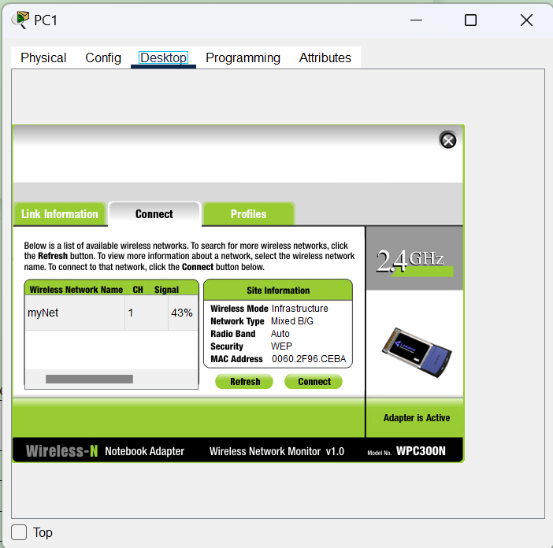

Fig 1.4: Connect field from Wireless PC window in CPT.

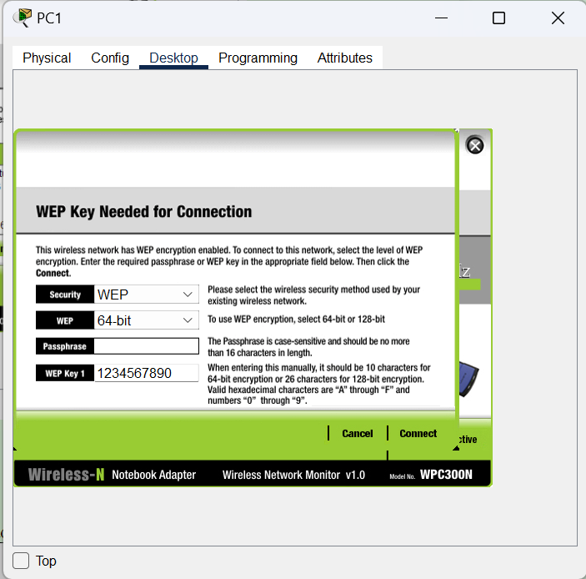

Fig 1.5: Giving the WEP key at Wireless PC window in CPT.

* 1. Configure the devices with the following IP addresses and Subnet Masks

First, from IP configuration, click on the ‘Static” bullet to select ‘static’, then assign these IP addresses and default gateway.

|  |  |  |  |
| --- | --- | --- | --- |
| **Host** | **IP Address** | **Subnet Mask** | **Default Gateway** |
| Router0 | 10.10.10.1 | 255.0.0.0 |
| PC0 | 10.10.10.2 | 255.0.0.0 | 10.10.10.1 |
| PC1 | 10.10.10.3 | 255.0.0.0 | 10.10.10.1 |
| Laptop0 | 10.10.10.4 | 255.0.0.0 | 10.10.10.1 |
| Tablet PC0 | 10.10.10.5 | 255.0.0.0 | 10.10.10.1 |

1. **Sending data across PCs and Router**
   1. Connection tests across devices

Ping PCs and Router by there IP addresses from another PC or Router in Command Prompt. If connection is there, four replies will come.

Command: ping<space>’IP address of some other PC or Router’

For first time communication, some packets may be lost.

Check that with all the other PCs and Router.

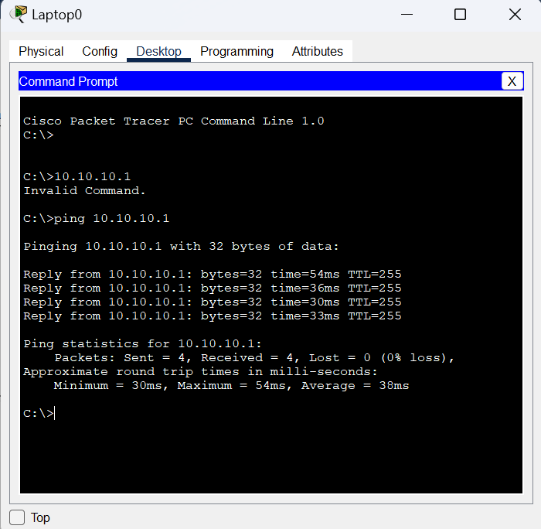

Fig 1.6: Pinging Router0 from Laptop0

1. **Simulation:**

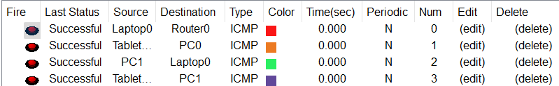

Fig 1.7: Successful packets travel across PCs

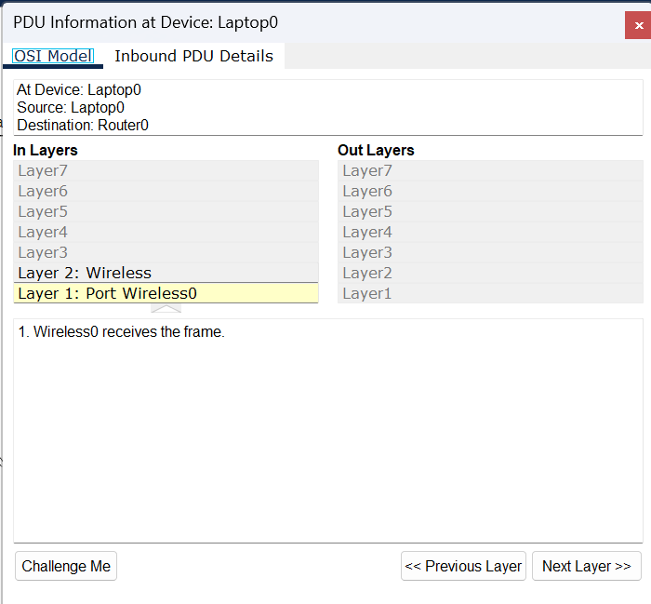

Fig 1.8: PDU information at the OSI model at Laptop0

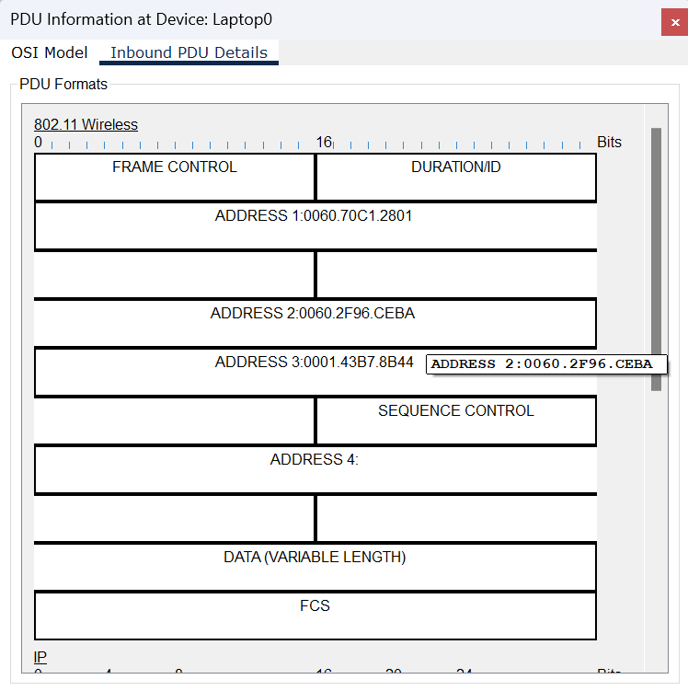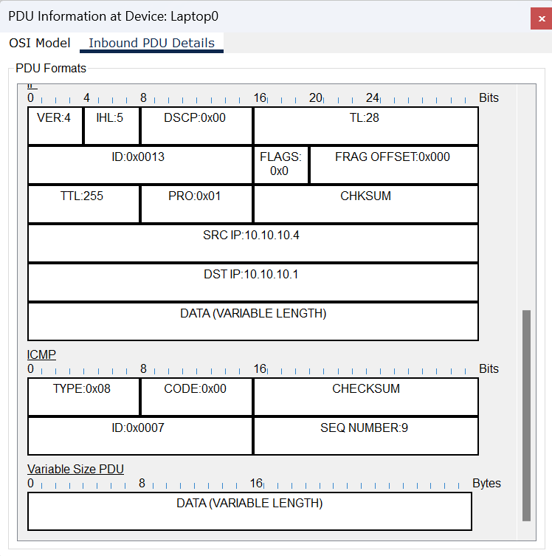

Fig 1.9: Inbound Protocol data unit details at Router0

**Conclusion:**

[Wireless networks are established without using cables of any kind](https://www.bing.com/ck/a?!&&p=fe3ede2771a9a71aJmltdHM9MTY4MTM0NDAwMCZpZ3VpZD0zZDNlMjZlMi00ZThmLTZmNmQtMWNmMi0zNDQyNGY4ZTZlYjMmaW5zaWQ9NTg1MA&ptn=3&hsh=3&fclid=3d3e26e2-4e8f-6f6d-1cf2-34424f8e6eb3&psq=wireless+networking&u=a1aHR0cHM6Ly9lbi53aWtpcGVkaWEub3JnL3dpa2kvV2lyZWxlc3NfbmV0d29yaw&ntb=1" \o "en.wikipedia.org" \t "https://www.bing.com/_blank). It uses radio waves to transmit data through free space. Wireless networking can avoid the costly and difficult installation of cables in buildings or between equipment locations.

Caution:

* Configure the devices after connecting them to the wireless access point.

**Lab Conclusion:**

From this lab we got to know about,

* Wireless Networking
* The networking where no cable is needed; communication can be established through free space.
* Reduces cable cost.
* Gives easy remote access.
* Less secure.